1. Python: A High-Level Language
- Python is a high-level programming language, designed to be closer to human language with an English-like syntax, making it easier to read and write.
2. Key Differences of Python from Other Languages
- Readability: Python's syntax is clean and concise, emphasizing readability.
- Versatility: Python supports multiple programming paradigms, including procedural, object-oriented, and functional programming.
- Community Support: Python has a large, active community of developers, offering abundant resources, libraries, and frameworks to help solve problems.
3. Creator of Python
- Python was invented by Guido van Rossum in 1991.
4. Purpose of Python's Creation
- Guido van Rossum created Python to be an easy-to-use language, aiming for simplicity and accessibility.
5. Applications of Python
- Python is used in various fields, including:
  - Web Development
  - Artificial Intelligence (AI)
  - Machine Learning (ML)
  - Data Science
  - Automation
  - Scientific Computing
6. Comments in Python
- Comments in Python start with the # symbol and are used to provide explanations or annotations within the code.
7. Rules for Declaring Variables
- Variable names:
  - Cannot start with a number.
  - Can contain numbers, but must start with a letter or underscore.
  - Cannot include special characters except for the underscore _.
  - Are case-sensitive.
8. Data Types in Python
- Integer: Whole numbers without decimal points.
- Float: Numbers with decimal points.
- String: Text or characters enclosed in quotes (single or double).
9. Indexing in Python
- Positive Indexing: Starts from the left, with the first character at index 0.
- Negative Indexing: Starts from the right, with the last character at index -1.
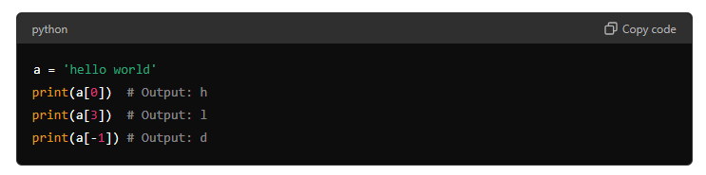
10. Slicing in Python
- Slicing is used to extract a range of characters from a string.
- The start index is inclusive, and the end index is exclusive.
- Omitting the start or end index defaults to the beginning or end of the string, respectively.
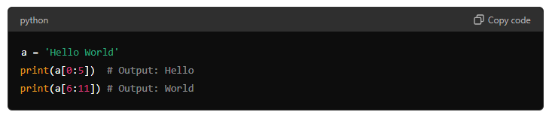
11. Negative Slicing
- Negative slicing allows extracting a substring by counting from the end.
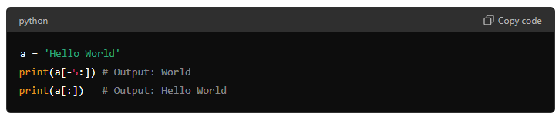
12. String Modification Methods
- Upper: Converts a string to uppercase.
- Lower: Converts a string to lowercase.
- Replace: Replaces a specified character or substring with another.
- Split: Splits a string into a list based on a specified delimiter.
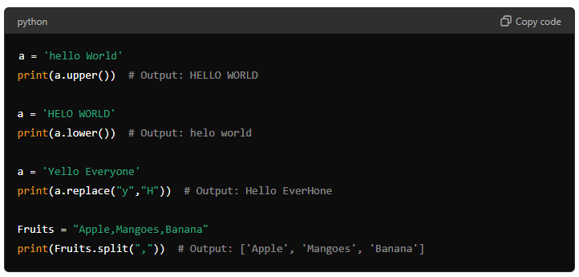
13. Boolean Data Type in Python
- Booleans represent True or False values, often used in comparisons or conditional statements.
